# Sharafestien - شرفشتــاين (Sharafestien)

## What is Sharafestien – شرفشتــاين?

**# Source**: **Chatgpt (GPT-5-Standard) at [8/27/2025]**

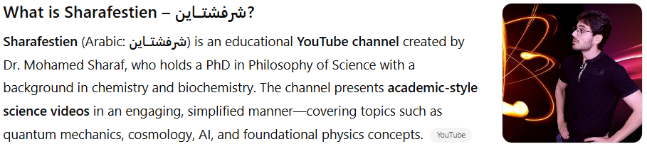

**Sharafestien** (Arabic: **شرفشتــاين**) is an educational **YouTube channel** created by Dr. Mohamed Sharaf, who holds a PhD in Philosophy of Science with a background in chemistry and biochemistry. The channel presents **academic-style science videos** in an engaging, simplified manner—covering topics such as quantum mechanics, cosmology, AI, and foundational physics concepts. ([YouTube](https://www.youtube.com/%40Sharafestien?utm_source=chatgpt.com), [vidIQ](https://vidiq.com/youtube-stats/channel/UC5lHUClILFbhw2x_cAI6POw/?utm_source=chatgpt.com))

## Key Highlights

**# Source**: **Chatgpt (GPT-5-Standard) at [8/27/2025]**

* **Platform:** YouTube
* **Language:** Arabic
* **Content Focus:** Popular science and academic content made accessible—from quantum mechanics and cosmology to artificial intelligence and biochemistry. ([YouTube](https://www.youtube.com/%40Sharafestien?utm_source=chatgpt.com))
* **Host:** Dr. Mohamed Sharaf — PhD in Philosophy of Science with specialization in Chemistry & Biochemistry. ([YouTube](https://www.youtube.com/%40Sharafestien?utm_source=chatgpt.com))
* **Subscribers:** ~719K (as of July 2025) ([vidIQ](https://vidiq.com/youtube-stats/channel/UC5lHUClILFbhw2x_cAI6POw/?utm_source=chatgpt.com" \o "شرفشتــاين (Sharafestien) YouTube Channel Stats - vidIQ))
* **Total Views:** ~45.48 million total views (recent snapshot; cumulative) ([vidIQ](https://vidiq.com/youtube-stats/channel/UC5lHUClILFbhw2x_cAI6POw/?utm_source=chatgpt.com" \o "شرفشتــاين (Sharafestien) YouTube Channel Stats - vidIQ))

## Summary Table

**# Source**: **Chatgpt (GPT-5-Standard) at [8/27/2025]**

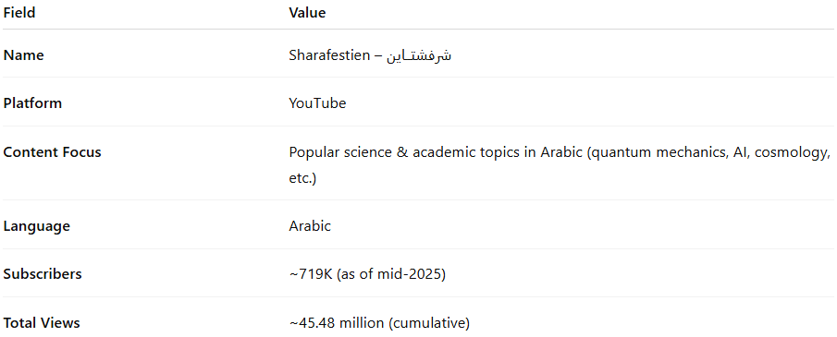

| **Field** | **Value** |
| --- | --- |
| **Name** | Sharafestien – شرفشتــاين |
| **Platform** | YouTube |
| **Content Focus** | Popular science & academic topics in Arabic (quantum mechanics, AI, cosmology, etc.) |
| **Language** | Arabic |
| **Subscribers** | ~719K (as of mid-2025) |
| **Total Views** | ~45.48 million (cumulative) |